St Mary’s Catholic Primary School

Foundation Phase Policy

Reviewed: January 2017
N Jones



Learning and Loving
Caring and Sharing
through
The message of Christ

St Mary’s Catholic Primary School is a happy community where we are loved and valued as individuals.

As Disciples of Jesus, we learn
together, pray together and
celebrate together as one in God’s love.

Together with parents/carers, the parish and the wider community, we prepare our children to live and build God’s kingdom on earth.


St Mary’s Catholic Primary School
Foundation Phase Policy
This policy statement sets out the basis for teaching and learning within the Foundation Phase of St Mary’s Catholic Primary School within the context of a faith school environment. It is founded on the principle that early education provides the essential foundation for all future learning.
In St Mary’s, we have carefully considered and analysed the impact of this policy on equality and the possible implications for pupils with protected characteristics, as part of our commitment to meet the Public Sector Equality Duty requirement to have due regard to the need to eliminate discrimination, advance equality of opportunity and foster good relationships.
Introduction
The ‘Foundation Phase Framework for Children’s Learning for 3-7 year olds in Wales’ is the statutory curriculum for all schools in Wales for all pupils from Nursery to Year 2.
The Foundation Phase encompasses the developmental needs of children. At the centre of the statutory curriculum framework links the holistic development of children and their skills across the curriculum, building on their previous learning experiences. The Foundation Phase curriculum promotes equality of opportunity and values and celebrates diversity. Children learn through first-hand experiential activities with the serious business of ‘play’ providing the vehicle. Through their play, children practise and consolidate their learning, play with ideas, experiment, take risks, solve problems, and make decisions.
Children will learn about their faith through high quality religious educational experiences equipping them with the knowledge, understanding and skills; appropriate to their age and capacity to reflect spiritually, think ethically and be aware of the commitments of everyday Catholic life.
First-hand experiences allow children to develop an understanding of themselves and the world in which they live. The development of children’s self-image and feelings of self-worth and self-esteem are at the core of this phase and belonging to a caring, diverse community enrich this whole experience. Engagement with their own and others’ beliefs and values will help develop good attitudes and dispositions so that children are instilled with a love of learning and a desire to go on learning.
The Foundation Phase curriculum is planned as a progressive framework that spans four years (3-7) to meet the diverse needs of all children, including those who are at an earlier stage of development and those who are more able.
A curriculum for young children should be appropriate to their stage of learning rather than focusing solely on age-related outcomes to be achieved. Children should move onto the next stage of their learning when they are developmentally ready and at their own pace.
The Foundation Phase environment promotes discovery and independence and places a greater emphasis on using the outdoor environment as a resource for children’s learning.

The statutory Areas of Learning in the Foundation Phase in a Catholic School are as follows:-
- Catholic Religious Education
- Personal and Social Development, Well-Being and Cultural Diversity
- Language, Literacy and Communication
- Mathematical Development
- Welsh Language Development (English Medium Schools only)
- Knowledge and Understanding of the World
- Physical Development
- Creative Development

The Developing Child 
Here at St Mary’s we are totally committed to providing opportunities for learning that will enable all children to develop the skills, knowledge and concepts they need to grow as confident and independent learners at a pace that is appropriate to their individual stage of development. We also recognise the vital importance of nurturing the emotional development and well-being of all children.

Objectives 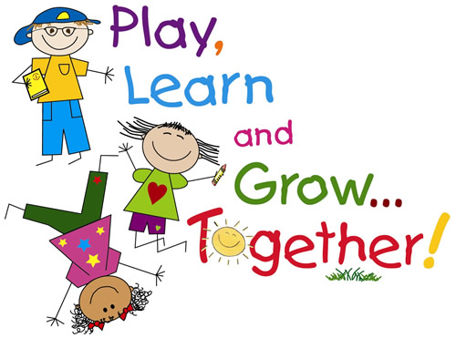
Here at St Mary’s Catholic Primary School we will:-
. Provide a welcoming, caring, positive environment which allows all children to feel secure and valued.
- Be aware of each child’s stage in their religious journey and, through the Come and See scheme, support and develop their knowledge, understanding and skills.
. Build an effective and long lasting partnership between home and school based on mutual understanding and respect.
. Provide a curriculum that builds upon the children’s own experience and which recognises the importance of play in early learning.
. Encourage enjoyment of learning, by planning so that children will:
Investigate, explore and question
Communicate thoughts ideas and feelings
Plan, experiment, test and take risks
Reflect their learning.
. Develop to the full each child as an active learner.
. Foster respect, tolerance, co-operation and independence.
. Provide a broad, stimulating and challenging curriculum that will provide the foundations for future learning.
. Plan and provide learning opportunities and resources appropriate to the stage of development of the child to ensure continuity and progression for all children to enable them to achieve their potential.
. Use the outdoor area as an extension of our classroom so the children have regular access to outdoor learning experiences.
. Celebrate the distinctive cultures, languages and traditions of Wales and encourage the children to use and communicate in Welsh to the best of their ability.
Staffing and Training 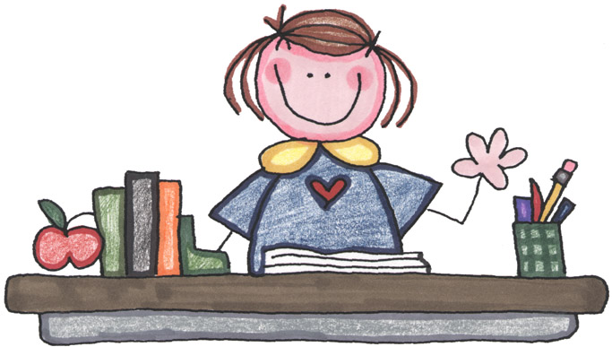
In line with Welsh Government guidelines, pupils aged 3-5 years are supported in St Mary’s by adult/child ratios of 1:8 and pupils aged 5-7 years are supported by ratios of 1:15.
Here at St Mary’s Catholic Primary School we are committed to working cohesively and collaboratively in Foundation Phase teams- Lower Foundation Phase (Nursery and Reception classes) and Upper Foundation Phase (Year 1 and Year 2 classes). These comprise of a range of qualified staff including teachers, nursery nurses and teaching assistants who share ideas and expertise and support each other in the planning and delivery of the curriculum.
(The staffing structure in the Foundation Phase at St Mary’s is shown in Appendix 1 )

All staff working within the Foundation Phase have accessed some form of Foundation Phase training either provided by the Local Authority or through ‘in-house’ training and the school is committed to providing further opportunities for on-going professional development wherever possible.
The Foundation Phase Curriculum at St Mary’s 
An effective Foundation Phase curriculum is one that is highly structured and
- ensures that children develop their learning building on what they can already do.
- is relevant and where appropriate content matches the different levels of young children’s needs.
- provides well- planned and purposeful activities for teaching and learning, both indoors and outdoors.
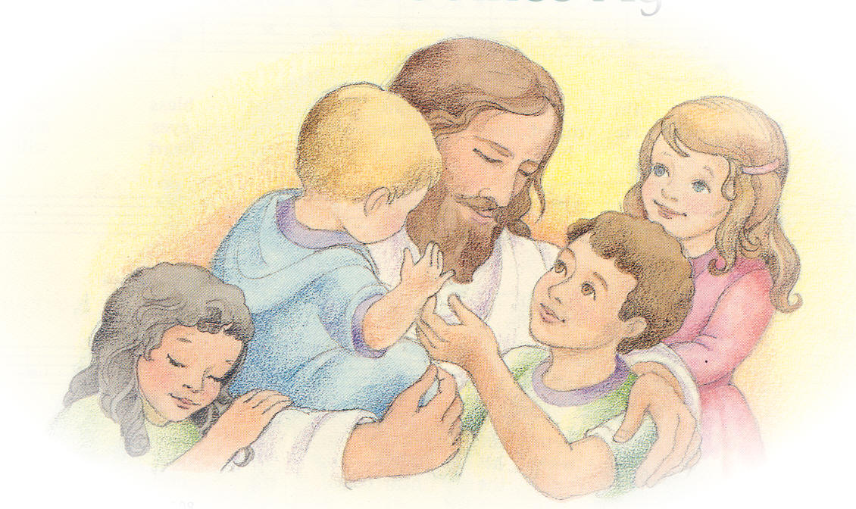
As a Catholic school Religious Education is taught as a discrete subject using the new Come and See scheme. Religious Education is at the forefront of the educational experience we provide at St Mary’s and represents 10% of the designated teaching timetable.
All teaching and learning will be very carefully planned and the following areas of learning are identified within the statutory framework.
- Personal and Social Development, Well Being and Cultural Diversity
Personal and Social Development is a pre-requisite for success in all areas of learning – providing an environment that enables all children to develop a positive sense of themselves and others. This is, therefore, at the heart of the Foundation Phase and should be developed across the curriculum.

- Language, Literacy and Communication Skills
Children are given experiences which help them to listen and respond to stories and songs, express needs and opinions and make choices, develop pre-reading skills and use marking implements in different situations and for different purposes. Developing reading and writing skills through knowledge of sounds and using these skills to read a range of texts and write for a variety of purposes is an integral part of the curriculum.
- Mathematical Development
Children are given experiences which help them to acquire and use mathematical language about shape, position, size and quantity, to recognise basic patterns, to sort, match order, sequence, compare and count familiar objects and begin to recognise numbers. As children develop they will be become more skilled in applying mathematical knowledge to solve problems, using a range of computational methods and extending their ability to record their work in a variety of ways.
- Welsh Language Development
Children are given experiences to develop their oral skills in Welsh through songs, rhymes, stories, games, ICT resources and role play as well as through everyday activities. As they develop they will be introduced to more complex language patterns and activities to promote reading and writing in Welsh.
- Knowledge and Understanding of the World
Knowledge and Understanding of the World develops skills to help children make sense of and understand the world around them. Children will be encouraged to develop skills of exploration, enquiry, experimentation, asking and finding the answers to questions. This area of the curriculum forms the foundation for science, geography, history, design and technology and ICT.
- Physical Development
Children are given experiences which help them to understand the concepts of health, hygiene and safety, to develop physical control, mobility, awareness of space and a range of manipulative skills. Children will be encouraged to enjoy physical activity in both the indoor and outdoor environment using a range of equipment.
- Creative Development
Creative Development includes art and music and creative movement – children are given experiences which help them to develop their imagination and creativity and their ability to communicate and express that imagination and creativity in a variety of forms.

In Foundation Phase, these areas of the curriculum are taught through a cross-curricular approach which acknowledges that young children learn in a holistic, all-encompassing way, not one which is compartmentalised and taught under traditional subject headings.
ASSESSMENT 
Assessment in the Foundation Phase is a continuous process linked with the planning and learning that is taking place. Assessments are made by observing the child across all aspects of their learning and development in every area of the curriculum. They will include a range of information gathered from a host of activities over time, which will build up a detailed picture of the child – what he/she can do successfully and what the next key steps of learning need to be.
On entry into the Foundation Phase, children will be assessed using the Compact form of the 'Foundation Phase Profile’. INCERTS assessment tool is utilised throughout St Mary’s from Nursery to Year 6 to monitor and track the progress of all pupils in line with the Foundation Phase Outcomes and National Curriculum levels (Key Stage 2)
On-going assessments will be carried out throughout the foundation phase in a variety of forms to enable teachers to assess what children can do and plan for the next steps in their learning journey. These can take the form of :- observational assessments in the continuous provision (post it notes), photographic evidence/ video footage, focused tasks assessments, structured assessments eg key word tests, spelling tests, time tables assessments
Assessment books are maintained containing samples of assessed pieces of work in Religious Education, Language, Literacy & Communication, Mathematical Development and Personal and Social Development from Reception to Year 2.
These, together with on-going informal assessments, evidence in children’s workbooks, post it notes and photographic evidence are utilised to enable accurate end of phase teacher assessments to be made.
Target setting and Peer/ Self- assessment 
Children from Nursery are introduced to ‘WILF,’ the Oxford Reading Tree character, who is looking for the children to set and achieve their learning targets. As the children progress through the Foundation Phase they are encouraged to identify their own targets for improvement and develop a good understanding of how to achieve them. From Year 1, ‘2 stars and a wish’ provides a vehicle for assessing their own work and identifying targets for improvement and ‘Rate your Work’ is a means by which children may reflect upon their own learning.
Children are also encouraged to assess the work of their peers through positive comments in the lower phase to ‘Rate your mate’ in the upper phase.
Achievement of individual or group targets is closely linked to our class sticker chart reward system (lower phase) 'Class Dojo' reward points on the computer (upper phase)

Celebrating Children’s Achievements 
All of the time children spend in school should be special but the early years of a child’s life in school are particularly precious and so, here at St Mary’s School, we celebrate their achievements in a variety of ways. This will include taking photographs, making videos, displaying children’s work around the learning environment, producing class assemblies as well as hosting open days, concerts and other special events to share this exciting time with family, friends and the local community.

Foundation Phase Staffing Structure Autumn 2015 (Appendix 1)
Nursery
Morning session- Mrs Cindy Myers (Teacher)
Afternoon session- Mrs Cindy Myers (Teacher)
Teaching assistants- Miss Mary-Anna O'Connell and Mrs Beata Talkowska

Reception
Parrots- Mrs Clare Hall
Penguins- Mrs Helen Schoonjans/ Mrs Lucy Shaw (0.5 job share)
Teaching assistants- Mrs Gill Davies (Senior TA/ NNEB)
Mrs Clare Edwards
Mrs Sophie Winward
Mrs Shirley Williams
Mrs Angela Hack
Mrs Fatima Nunes

Upper Foundation Phase
Year 1 Wrens- Miss Karyn Wright
Teaching Assistant- Mrs Jane Gledhill (HLTA)
Year 1 Owls- Mrs Natalie Jones(Senior Manager)
Teaching assistant- Miss Natalie Ashfield
Year 2 Robins- Miss Siobhan Davies
Teaching assistant- Mrs Shelly Griffiths
Year 2 Sparrows- Miss Laura Windsor
Teaching assistant- Mr Dave McGuire

