YSGOL GYNRADD Y SANTES FAIR
ST MARY’S CATHOLIC PRIMARY SCHOOL

Ebost: mailbox@stmarys-wxm-pri.wrexham.sch.uk
Safle: www.stmarys-wxm-pri.wrexham.sch.uk
Tel: 01978 352406
Ffon: 01978 352406

21st December 2018

Pope Francis’ Thought for the Day  Joy, prayer and gratitude are three ways that prepare us to experience Christmas in an authentic way. | Welsh Words/Phrases  Nadolig Llawen a Blwyddyn newydd dda – Merry Christmas and Happy New Year  Cyfarchion y Tymor – Seasons Greetings  Mair a Joseff – Mary and Joseph  Baban Iesu – Baby Jesus  Sion Corn – Father Christmas
END OF TERM - Thank you for another happy and successful term in St Mary’s. Continued parental support is greatly valued. Diolch o galon. We hope that all families enjoy a very peaceful and happy Christmas and wish you all every blessing for the new year. (BACK TO SCHOOL ON TUESDAY 8th JAUARY 2019)
Christmas gifts
On behalf of all members of school staff, may I thankyou all for your very generous Christmas gifts and beautiful Christmas cards. Your kindness is very much appreciated. God bless you all.
Well Done
To Efan who has passed his 2nd Kup Red Belt A-Pass in Tae Kwon-Do. Evan has completed the White Tiger Tae Kwon-Do program. Katy has received a gymnastics award and Alicja has passed her dance exam. Natasza has received a certificate for 9th Kup White Belt in Tae Kwon-Do. Alfie has completed the White Tiger Tae Kwon-Do program.

Headteacher’s Awards

NAME | REASON
Izzy | Being a supportive talk partner
Maja | For lovely work presentation
Elisha | For being a fantastic talk partner
Zuzanna
Alise | For being creative
Alex | For always smiling
Jessica | For challenging herself
Igor | For superb work on Banksy
Buvidu
Tamzin | For being an incredibly helpful young lady

End of Term Advent Mass
Another beautiful whole school Mass led by Canon and our wonderful Year 4 children. Da iawn pawb and thank you to Foundation Governors, Mrs Liz Davies and Mrs Esther Bennington for celebrating with us today.

Sacrament of Reconciliation
Thank you to Canon Simon Treloar, Canon Lordan, Fr Reginald and Fr Spigniew for coming to school on Monday to offer the Sacrament of Reconciliation to our Junior children. We very much appreciate your time to support our children in their spiritual preparations before Christmas.

Christmas Masses and Services 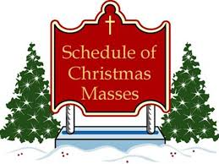

St Francis of Assisi, Llay
Monday 24th December 5.30pm Carols, Mass 6pm
Tuesday 25th December 11am Mass

Christ the King, Rossett
Tuesday 25th December 9 am

St Mary’s Cathedral, Wrexham
Mon 24th THE NATIVITY OF OUR LORD JESUS CHRIST (SOLEMNITY) - CHRISTMAS VIGIL
Tues 25th THE NATIVITY OF OUR LORD JESUS CHRIST (SOLEMNITY) - CHRISTMAS DAY
Wed 26th ST STEPHEN, THE FIRST MARTYR (FEAST)
Thurs 27th ST JOHN, APOSTLE AND EVANGELIST (FEAST)
Fri 28th THE HOLY INNOCENTS, MARTYRS (FEAST)
Sat 29th Mass for Altar Servers - 12 noon at the Cathedral

St Mary’s Church, Ruabon
Monday December 24th, 4pm Crib Service, come dressed as a character in the story
11.30pm Midnight Mass
Tuesday December 25th, 9am Holy Communion

St Anne’s, Wrexham
Sorry, no Christmas Mass Times have been added by this parish.
Please contact them for Mass Times over Christmas as they are likely to change and so will not be correct on this site. However, here is some general information:
- Monday 24th December is Christmas Eve - if there is "Midnight Mass" it may be earlier than Midnight.
- Tuesday 25th December is Christmas Day - there are not normally Masses in the afternoon or evening
- Wednesday 26th December is St Stephen`s Day

Christmas Cinema Treat
A big thank you to the Friends’ for part funding the cinema treat for all children in Reception to Year 6 classes. It sounds like the children had a lovely time in the Odeon and the staff told me how beautifully everyone behaved! Da iawn St Mary’s children.

Nursery Christmas Party
The Nursery classes, Storks and Swans, met for their Christmas party on Wednesday. They met Father Christmas and he gave them a present (with a little help from The Friends!) They danced together, ate together and made some new friends. Merry Christmas everyone!

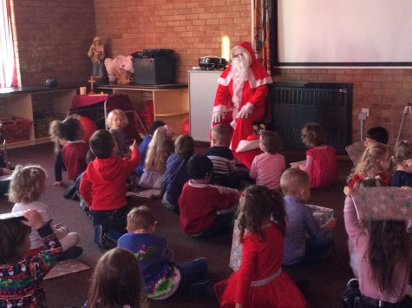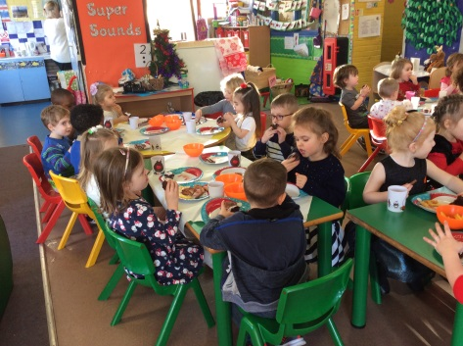

VERY EXCITING… COMING IN THE NEW YEAR…
ST MARY’S CREDIT UNION SAVINGS ACCOUNT

In January we will be starting an exciting partnership with the Credit Union Bank. The pupils, together with Governors and volunteers, will be running a saving scheme in school. Children will be able to start a bank account and save with the Credit Union Bank but pay the money in fortnightly in school. Initially it will be for year 6 but then will be rolled out to the other years through the Summer Term. There will be a grand launch in the second week back, more details on this will be forwarded to you over the Christmas holidays.

Singing Squad- Carol Singing
Last Tuesday 21 children from Singing Squad braved the bad weather to entertain the residents of Stansty Home. The children sang a range of Christmas carols and songs. The children sang beautifully bringing a tear to the eyes of one staff member. The children were then treated to a drink of hot chocolate.

We have been asked to sing at the home again in the Spring Term.

Reward Slip draw
The winners of the December Reward Slip draw are Daniel and Mari.

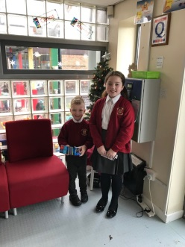

CHESTER ZOO
On Tuesday Year 6 had a visit from Adele from Chester Zoo who delivered a fabulous workshop on sustainable palm oil. This was a perfect end to our latest 'Big Question' about the use of unsustainable palm oil and the affects that it has on critically endangered animals such as the orangutan. A big thank you to Chester Zoo for helping us to get involved in their Palm Oil Challenge!

Forthcoming School Council and Eco Meetings
Eco – 1st February
School Council - 16th November and 8th February
Joint meeting – 7th December

THESE ARE THE CONFIRMED TEACHER TRAINING/ INSET DAYS 2018/2019
(No School for children on these days)
Monday 7th January 2019
Monday 29th April 2019
Monday 22nd July 2019

Twitter
We are now on Twitter. Please follow us @stmaryswxm to keep up to date with events, activities and whole school news.

Awesome Attendance!

Week Beginning 10th December 2018
The Foundation Phase Attendance Award this week has been presented to:
Owls Class 98.4%
Llongyfarchiadau – Congratulations!

Week Beginning 10th December 2018
The Key Stage 2 Attendance Award this week has been presented to:
Alyn Class 100%
Llongyfarchiadau – Congratulations!

Foundation Phase Classes |  |  | Key Stage 2 Classes
Stork | 91.3% |  | Clywedog | 98.4%
Swan | 88.4% |  | Taff | 99.2%
Penguins | 97% |  | Alyn | 100%
Parrots | 94.3% |  | Conwy | 99.2%
Owls | 98.4% |  | Dovey | 99.6%
Wrens | 96.3% |  | Gwaun | 97.9%
Sparrows | 94.6% |  | Gwenfro | 98.4%
Robins | 95.8% |  | Dyfrdwy | 94.3%

Well done to those classes who have achieved or exceeded our school target of 96%!

