ST MARY’S CATHOLIC PRIMARY SCHOOL

Assessment, Recording and Reporting Policy

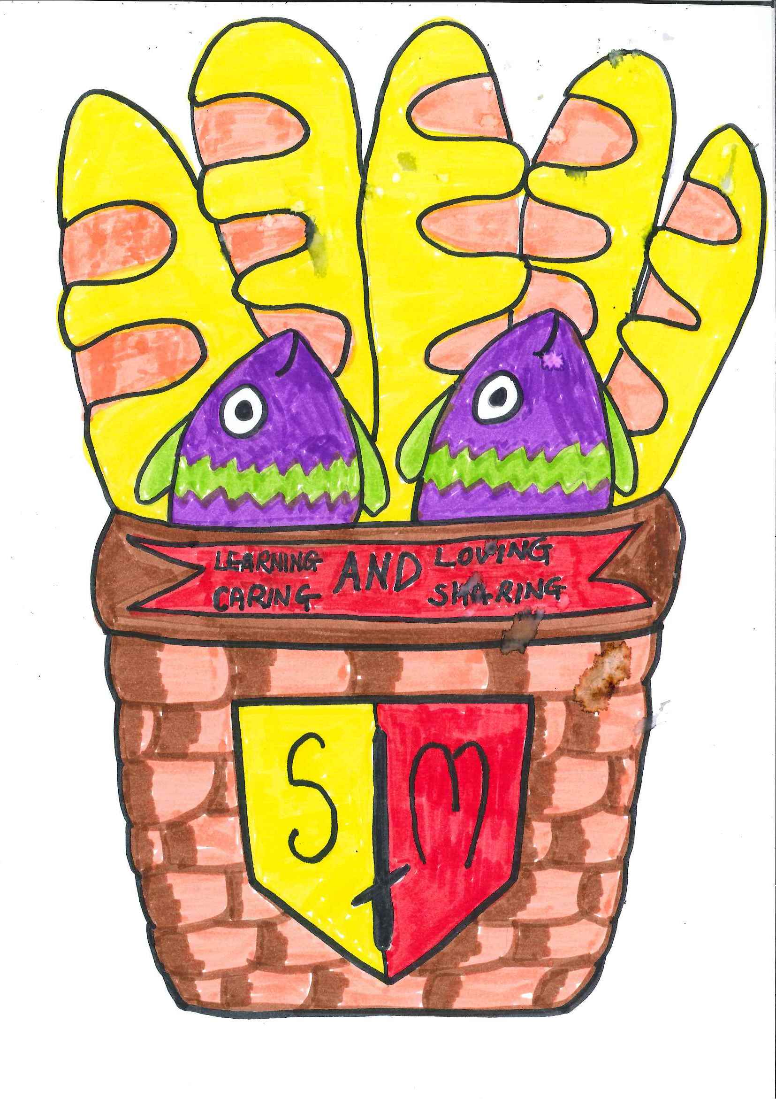
Learning and Loving
Caring and Sharing
through
The message of Christ

St Mary’s Catholic Primary School is a happy community where we are loved and valued as individuals.

As Disciples of Jesus, we learn
together, pray together and
celebrate together as one in God’s love.

Together with parents/carers, the parish and the wider community, we prepare our children to live and build God’s kingdom on earth.

Introduction

This policy reflects the values and philosophy of St Mary’s Catholic Primary School in relation to Assessment, Recording & Reporting. It provides a framework for all staff to follow and provides guidance on how, when and why we assess children’s work. This policy also identifies the characteristics of good practice and how Assessment, Recording & Reporting is monitored in St Mary’s.

Consistent day to day assessment and recording of pupil attainment is an integral part of teaching and learning at St Mary’s.

Assessment is used effectively to:
- Provide information to teaching staff about how a pupil’s learning is progressing in relation to his/ her targets
- Identify key strengths and areas for further development
- Inform the planning of future teaching and learning experiences

Aims and Objectives

The aims and objectives of assessment in our school are:

- to enable each child to achieve their full potential, raising standards of achievement and attainment;
- to enable our children to demonstrate what they can do, what they know and understand;
- to help our children understand what they need to do next to improve;
- to allow teachers to plan experiences that accurately reflect the needs of each child;
- to allow for formative and summative aspects of assessment;
- to provide regular information to parents to enable them to support their child’s learning at home;
- to provide the headteacher, governors and staff with information that allows them to make judgements about the effectiveness of the school.

Types of Assessment

- Formative – on-going assessment which takes place during the daily interaction between the teacher and the child (talking, listening, observing, questioning, written and practical activities, marking etc.) in order to identify the child’s progress.
- Diagnostic – the detailed analysis of specific aspects of performance, in order to determine the precise nature of particular strengths and/or areas for development.
- Summative – accumulative evidence of what a child knows, understands and can do, at a particular time, e.g. at the end of the year, when reporting to parents/carers or at the transfer between classes.
- Evaluative – information to evaluate the effectiveness and appropriateness of the teaching and learning.

Planning for Assessment

Our Schemes of Work detail focus skills and links to the Foundation Phase Framework, the National Curriculum, the Literacy and Numeracy Frameworks and the Digital Competence Framework.

Teachers plan a range of stimulating learning experiences for the children making the purpose/ form explicit in order that children have a clear understanding of how they can be successful in their learning. Teachers use their detailed knowledge of each child and plan work to both challenge and support learners. Teachers strive to ensure that all experiences are appropriate to each child’s stage of learning. Teachers monitor the progress of all children and provide feedback during and following tasks Teachers maintain their own class assessment records for reading, spellings, times tables (as appropriate.) Teachers share a range of assessment information during team planning sessions and this is used to inform future planning.

Whole School on- going teacher assessment in Religious Education

In Religious Education, pupils’ work is assessed at the end of each topic in line with Diocesan guidance. One topic per term is ‘formally’ assessed and a best fit level is awarded and the remaining topics are ‘informally’ assessed, levelled and marked with a fish symbol.

On- going teacher assessment for learning in the Foundation phase
Opportunities for developing pupils' oracy skills will be planned across all areas of the curriculum. At least one learning task per term will be assessed and a best fit outcome awarded. On-going teacher assessments and observations are recorded in teachers' planning and oracy records.
Weekly reading sessions are carefully planned to ensure that pupils read a range of genres to include fiction, non- fiction, poetry, play scripts etc. and develop their reading skills in a variety of contexts. Teachers assess pupils' reading skills in relation to the Foundation Phase outcome statements and their developing reading skills using the school 'Teachers' Reading records.'

Writing opportunities are carefully planned across each year group to ensure that all children understand the characteristic features of different forms of writing. In addition, children are given a range of opportunities to reinforce and develop their writing skills across other curriculum areas e.g. Knowledge and Understanding of the World and Religious Education, and in all areas of Continuous Provision e.g. Builders' Yard, Writing Rainbow.
All pieces of written work are ‘live- marked’ and children are given the opportunity to respond to feedback immediately. EBIs may be identified and children respond as appropriate. Any changes will be completed in pencil. Teachers will use a green pen to identify areas for improvement i.e. spelling errors, more ambitious choice of vocabulary etc. Literacy based assessments are recorded on the children’s individual assessment grids in their literacy workbooks.

At the end of a unit/s of work/ topic in Maths, an assessment will be carried out to review pupils’ understanding of concepts taught. Numeracy based assessments are recorded on the children’s individual assessment grids in their numeracy workbooks.

PSD observational assessments and tasks are recorded on the children’s individual assessment grid. A range of evidence is used for assessment purposes.

On- going teacher assessment for learning in Key Stage 2

Literacy experiences within each topic are planned holistically thus incorporating oracy, reading and writing into each ‘Big Question’.

Oracy tasks for each ‘Big Question’ are assessed using colour-coded class oracy assessment sheets.

Weekly reading sessions are carefully planned to ensure that pupils read a range of genres to include fiction, non- fiction, poetry, play scripts etc. and develop their reading skills in a variety of contexts. Where appropriate, reading is planned in a cross- curricular way and is linked to the ‘Big Question’. Teachers assess pupils' reading skills in relation to the National Curriculum statements and their developing reading skills using the school 'Teachers' Reading records’ in Years 3-5 and the colour-coded reading assessment sheets.

For each ‘Big Question’, writing opportunities are carefully planned in a cross- curricular way to ensure that all children understand the characteristic features of different forms of writing. Children are given a range of opportunities to reinforce and develop their writing skills across all areas of the curriculum e.g history, Religious Education and science and during 'Big Write' sessions.
Writing assessments are recorded on the children’s individual assessment grids in their literacy workbooks and a best fit level is awarded for each final written task per ‘Big Question’.
All pieces of written work are ‘live- marked’ and children are given the opportunity to respond to feedback immediately.

Children begin their piece of writing on the right -hand page leaving the left page (EBI page) for the redrafting process. Areas for improvement will be highlighted by the teacher in order to raise the standard and or NC Level of the piece of work.

Teachers will also identify areas for improvement within the child’s piece of work relating to either spelling, grammar and punctuation errors using the agreed marking code. All response to feedback made by children is in a BLACK pen on the original draft

Following the redrafting process, a final draft will be completed where appropriate I.e. to send a letter to the Mayor. The final draft will be formallyassessed and a best fit Level awarded.

Maths

At the end of a unit/s of work/ topic in Maths, an assessment will be carried out to review pupils’ understanding of concepts taught. Numeracy based assessments are recorded on the children’s individual assessment grids in their numeracy workbooks.

Science and Welsh

At the end of a topic/ unit of work in Science and Welsh an assessment will be carried out to review pupils’ understanding of concepts taught. This will be formally assessed, and a best fit Level awarded. Science based assessments are recorded on the children’s individual assessment grids in their numeracy workbooks.

Assessment for Learning Strategies

Constructive feedback with pupils ensures that they know how well they have achieved and what they need to do in order to improve their work. Children should be given opportunities to develop the skill of identifying for themselves how well they are doing and what they need in order to make improvements.
All staff adhere to the agreed feedback and marking policy ensuring a consistent approach across the school. This is being reviewed at present under the guidance of the AfL SDP development team. (Please see St Mary’s Interim Marking and Feedback Policy 2018).

Children from Nursery are introduced to various Assessment for Learning strategies. ‘Talking Partners’ are used in all areas of the curriculum as a way to support, challenge and ensure quality talk. It allows time for children to think before answering and supports less confident children as they have time to talk to their partner and think about their response. The ‘No Hands Up’ rule is used to encourage all children to work with their Talking Partner to find answers and encourages all children to be actively involved. ‘Learning Zone, Comfort Zone and Panic Zone’ are used to help the children self-assess and decide if their work is of the appropriate level of challenge. If work is too easy and children are in the ‘Comfort Zone,’ they are encouraged to try something a little more challenging to move them to their ‘Learning Zone’.

Statutory Assessment in the Early Years
During the first six weeks in Reception class, all children are statutorily assessed against the Foundation Phase Profile (FPP).
The FPP assesses children’s abilities and development in 4 areas of learning:
- personal and social development, well-being and cultural diversity
- language, literacy and communication skills (incorporating the literacy component of the National Literacy and Numeracy Framework [LNF])
- mathematical development (incorporating the numeracy component of the LNF)
- physical development.
Assessments are carried out in the form of observations and formative assessments.
The data gathered is used to provide an early indicator for end of Foundation Phase targets. This data also enables staff to make an early identification of children who may require ALN support or be MAT pupils. It also allows the school to gain value added attainment information.

During the first six weeks in Nursery class, the same assessment process is conducted, however this is not a statutory requirement.

Teachers verbally feedback the information gathered from the FPP assessments to the parents of both Nursery and Reception children during the autumn term.

Administration of National Tests in Years 2 to 6

Welsh Government National tests in Reading, Procedural Maths and Numerical Reasoning are completed by children in Years 2 to 6 children during a specified period in the month of May. The tests are internally marked and verified and results are uploaded onto the DEWI website within the designated assessment period. Before the end of the summer term, Standardised Scores and other assessment information is available for schools on the DEWI website to analyse and identify areas for further development. The GWe Diagnostic tools may be utilised where appropriate alongside in-house comparative assessment information at the end of the summer term and the beginning of the autumn term in order to identify areas of strength and ways forward to inform future planning of teaching and learning strategies.

Whole School Target Setting and Tracking Pupil Progress in St Mary’s

Whole school performance targets are set in the autumn term and these are reviewed regularly throughout the year to ensure that they continue to accurately reflect pupil progress. Pupil Progress meetings are timetabled termly where teaching staff meet with the SMT to review progress information.
Following these meetings, the SMT and ALN Co review all progress information to ensure appropriate challenge, support and or intervention is provided. A data summary sheet is produced and shared with staff ang governors.
Foundation Phase staff set targets in Religious Education, Language, Literacy & Communication (LLC), Mathematical Development (MD) and Personal, Social Development (PSD). Key Stage 2 staff set targets in Religious Education, English, Maths, Science and Welsh Second Language.

The pupil performance targets are inputted into the school’s bespoke Excel Target Tracking system. The system provides a range of progress information for detailed analysis by the Headteacher and Senior Managers to ensure that all children are being appropriately challenged/ supported to achieve their potential, i.e. overall performance data in FPI and CSI (at least national expected progress in all 3 core AOL/ subjects), individual AOL/ Subject performance data, comparative gender performance data, performance data for eFSM/ EAL pupils, Salford Reading tests, National Test information etc.

Monitoring accurate assessments and standards through ‘Listening to Learners’ Monitoring exercises.

A timetable for focused learner voice monitoring is set at the beginning of each academic year and shared with all staff. This is a very effective tool to monitor the standards of pupils’ work in relation to their predicted outcome/ levels, to monitor appropriate differentiation (including support and challenge), to monitor progression of skills throughout the school, to monitor adherence to agreed policies and procedures and to match planning to work in pupils’ workbooks. In addition to the agreed focus, adherence to the Marking and Feedback and Presentation policies is also monitored. All teaching staff have the opportunity to participate in the process alongside the Headteacher and Senior Managers. Feedback is provided for all staff and details identified good features including good practice to share and areas for further development.

Tracking pupil progress using PUPIL ASSESSMENT GRIDS and ACTUAL PUPIL PROGRESS SPREADSHEETS

Since September 2017, differentiated 'Pupil Progress Grids' have been implemented in all year groups reflecting the attainment targets in the core Foundation Phase areas of learning and National Curriculum subjects.
Pupils' end of phase/ key stage predicted outcomes/ levels are clearly identified by their class teacher at the top of their subject Pupil Progress Grid and these predictions maybe reviewed at any time.
Whilst marking a piece of work, teachers date the relevant attainment target on the grid at the front of a child's workbook which relates to the learning task. Once a teacher is confident that a statement has been achieved, the statement will be highlighted in GREEN.

At the end of an academic year, all teachers review all assessment information and record the actual outcome/ level of each child in the core areas.

Standardisation in St Mary’s

A timetable for standardisation of pupils’ work in the core subjects/ AOLs is set at the beginning of each academic year. During standardisation meetings, staff work in teams to agree a ‘best fit’ level/ outcome for a selection of pupils’ work utilising the Foundation Phase Framework and National Curriculum outcome/ level descriptors. Standardised work is kept for future reference when assessing pupils’ work and to ensure that expectations and procedures are accurate.

Year 2 and 6 Standardisation and Moderation

Children’s own workbooks I.e. Learner profiles depicting a range of work reflecting all attainment targets at Foundation Phase Outcomes 4, 5 and 6 in LLC, MD and PSD and National Curriculum Levels 4 and 5 in Key Stage 2 English, Maths, Science and Welsh are used annually for cluster standardisation and moderation to ensure assessment procedures and expectations are robust, accurate and fair.
AOL | LLC | MD | PSD
Minimum evidence required for moderation | 3 oracy tasks  3 reading tasks (at least 1 non- fiction)  3 writing tasks (At least 1 extended story and 1 non- fiction based text) | Best fit Coverage showing a range from each element of the maths curriculum (including maths across the curriculum) | A range of evidence to form a best fit judgement e.g. photographs, observations, focus tasks
SUBJECT | ENGLISH | MATHS | SCIENCE | WELSH
Minimum evidence required for moderation | 3 oracy tasks  3 reading tasks (at least 1 non- fiction)  3 writing tasks (At least 1 extended story and 1 non- fiction based text) | Best fit Coverage showing a range from each element of the maths curriculum (including maths across the curriculum) | Best fit Coverage showing a range from each element of the science curriculum. | 3 oracy tasks  3 reading tasks (at least 1 non- fiction)  3 writing tasks (At least 1 extended story and 1 non- fiction based text)

Assessing Reading using the Salford Reading Test in St Mary’s

The Salford Reading Test has been introduced to carefully assess and track pupil progress in reading (since September 2016.) Pupils in Years 2 to 6 are tested once per term and children in Year 1 are tested each term once they turn 6 years old.
Reading test results are carefully analysed and are used to generate a ‘Reading Age’, a ‘Reading Accuracy Standardised Score’, a ‘Comprehension Age’ and a ‘Comprehension Standardised Score’. This information is then used to identify areas of strength and development for each child in relation to their reading accuracy and comprehension skills and teachers group children accordingly to best support the individual needs of all learners. Additional reading intervention support is provided where a need is identified. Progress of all learners, including identified groups of learners such as eFSM/ ‘intervention’ children, is carefully tracked each term in relation to previous performance and is reported to parents during the termly Parents’ evenings.

Reporting to parents

A range of strategies are used to ensure that parents are kept fully informed of their child’s progress in school. The school operates an ‘open door’ policy and parents are encouraged to contact the school if they have concerns about any aspect of their child’s work.
Each term, parents have the opportunity to attend Parents’ Evenings along with their child. During the autumn term, Parents’ Curriculum Workshops are held in Reception to Year 6 classes and provide parents with information about what their child will be learning during the year, appropriate teaching and learning strategies and ways parents can support their child’s learning at home. In addition, an introductory Parents’ evening is held where pupils’ progress and identified broad learning targets are shared with parents.
During the summer term all parents receive a full written report of their child’s progress and achievements during the year. In this report, target areas for the next school year are identified. Teachers write individual comments on all areas of learning in the Foundation Phase and all subjects of the National Curriculum and Religious Education. In reports for pupils from Year 2 to Year 6, results from National Reading and Numeracy tests are enclosed, and at the end of Foundation Phase (Year 2) and the end of KS2 (Year 6) details of teacher assessments for outcomes / levels achieved are also provided.
Comments from parents are encouraged and a Parents’ Comment slip is attached to the report for completion and return to the child’s class teacher
During the final term, parents are invited to discuss the child’s written annual school report and the targets identified in it for the next school year.

Monitoring and Evaluation

Assessment, Recording and Reporting procedures are monitored by the Headteacher and Senior Managers, who will ensure that judgements continue to be consistent and accurate and that assessment arrangements are both effective and manageable.

Monitoring of teaching and learning in relation to teachers’ Performance Management targets takes place termly by the Headteacher, Senior Managers and Senior Teachers. Pupils’ work is monitored regularly in line with the school’s Monitoring timetable by the Headteacher, Senior Managers and all teachers on a rota basis.

